ASSIGNMENT README FILE

CARSELLING

1. STEP 1:

First of all I have created one index.html page which will open by default as soon as we open the link <https://the-cars-hub.000webhostapp.com/>

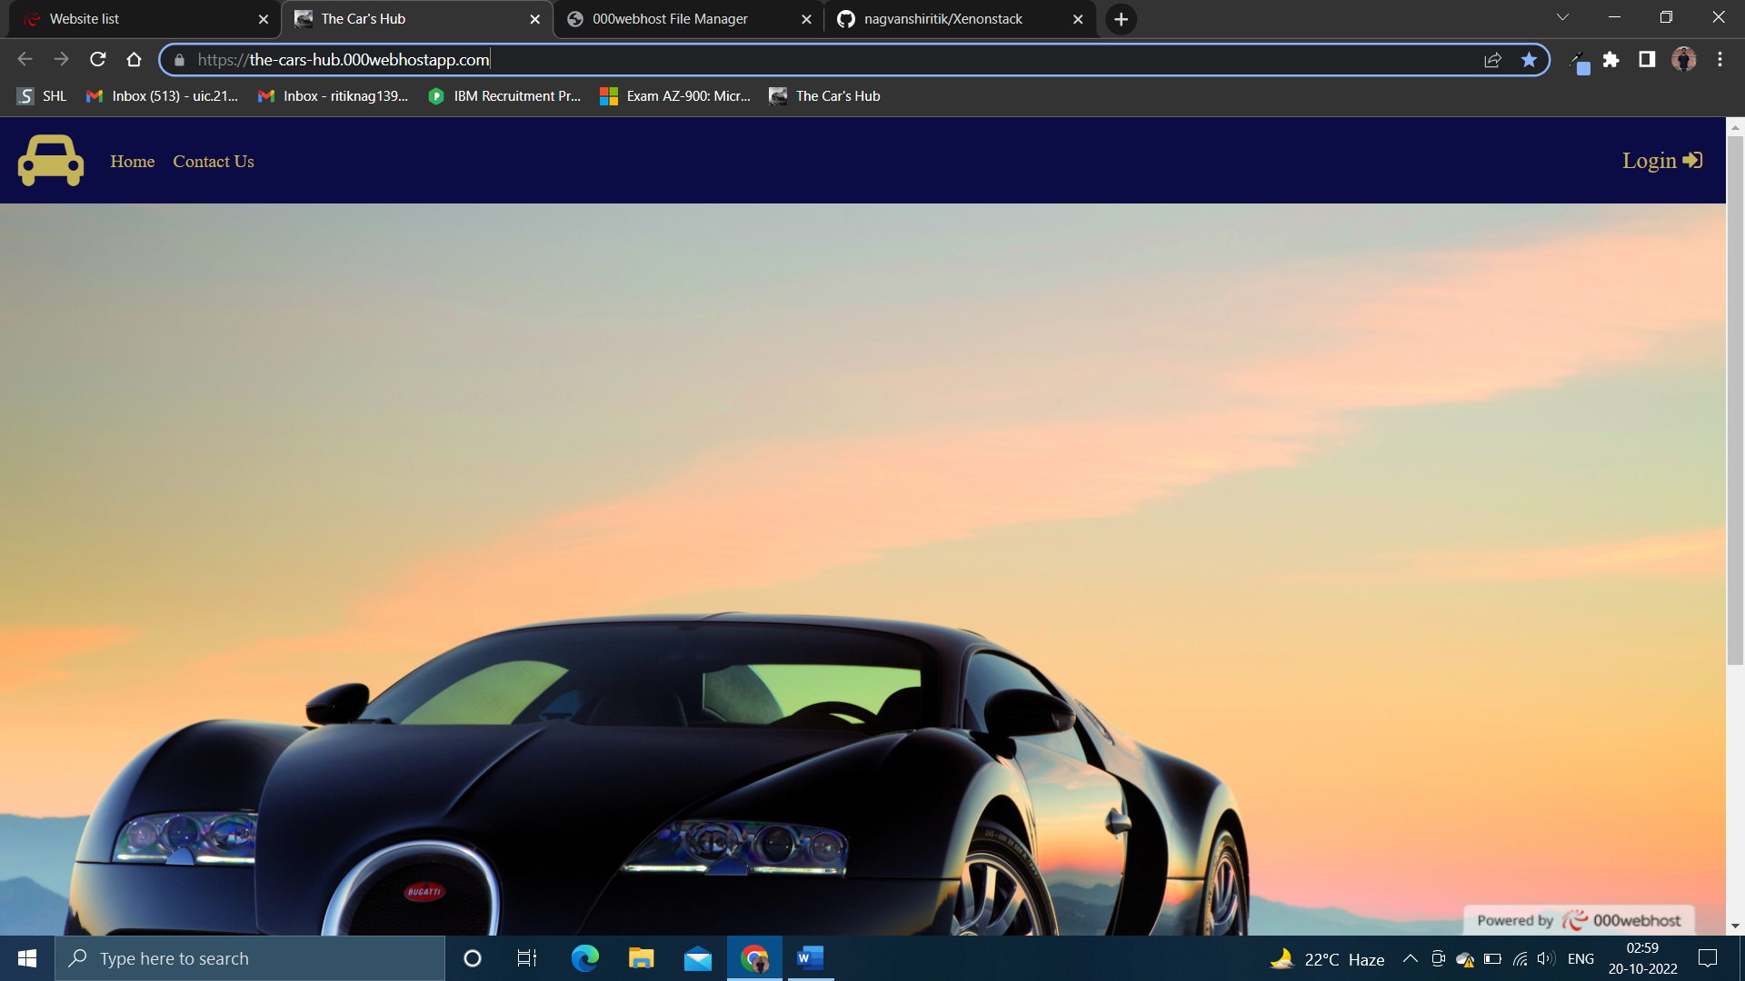

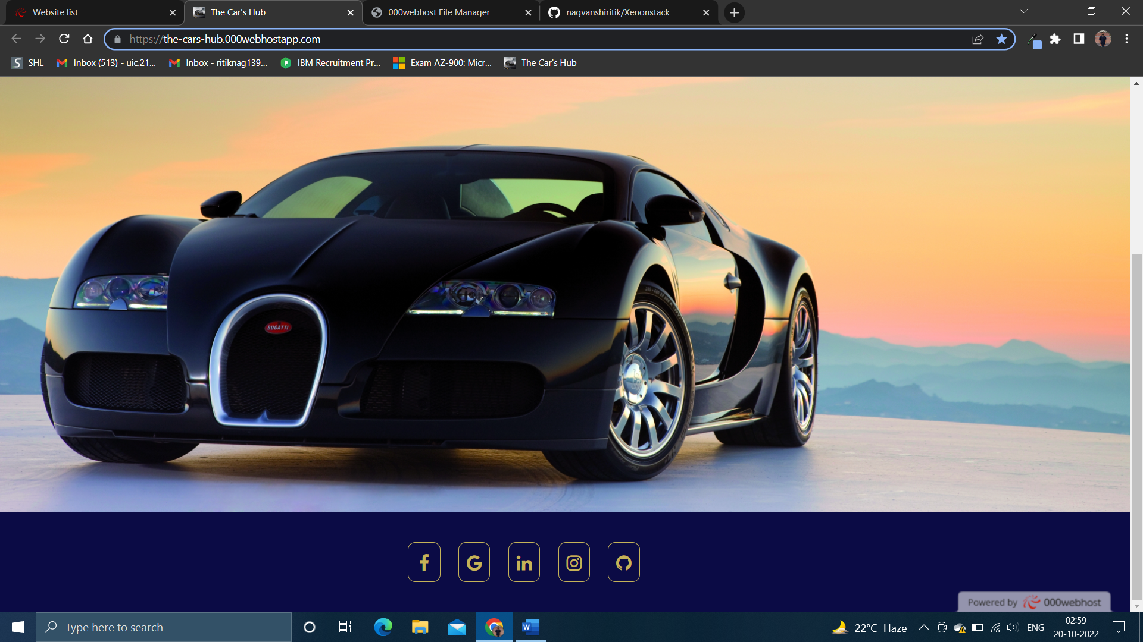

If we open in mobile it look like:

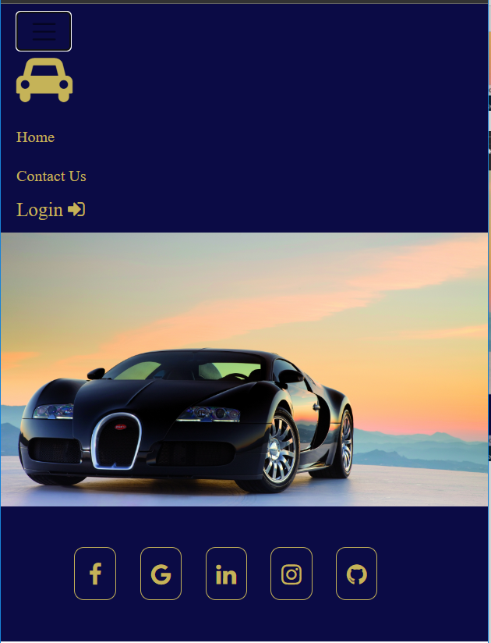

1. STEP 2:

Here we have two options one to login and second one to visit contact us page

If we click on login the page will appear like:

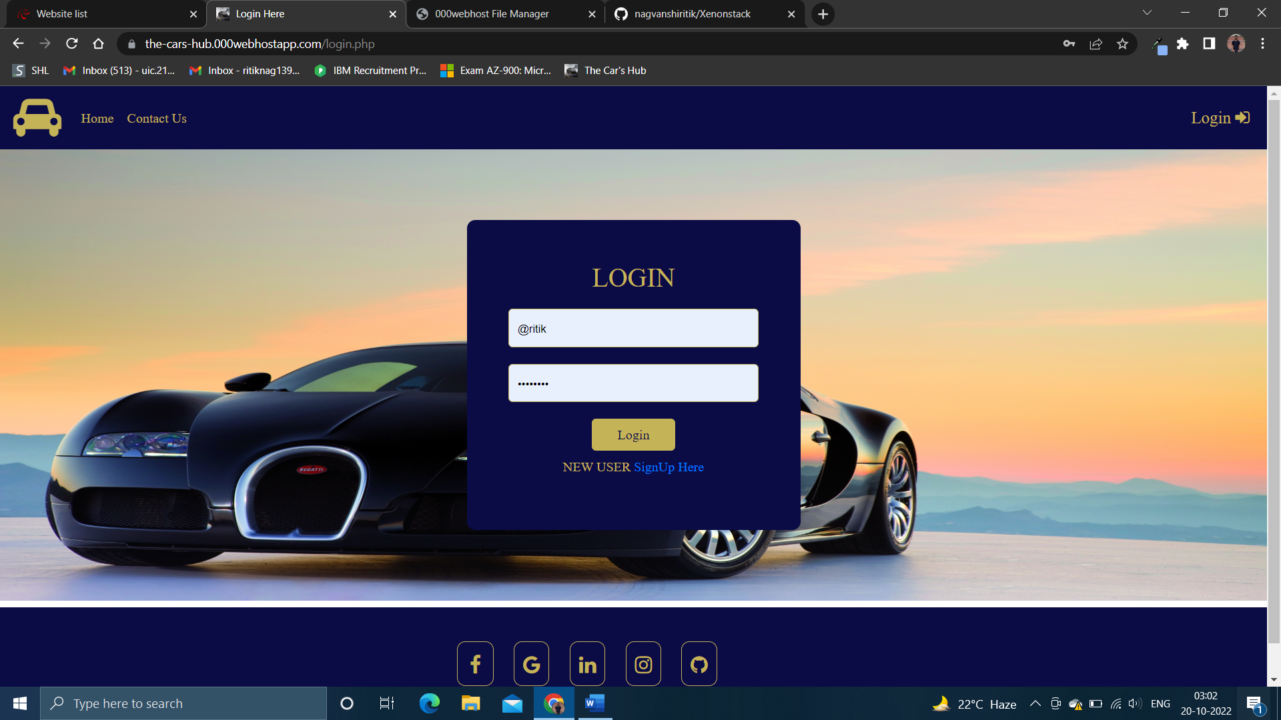

In mobile it will look like:

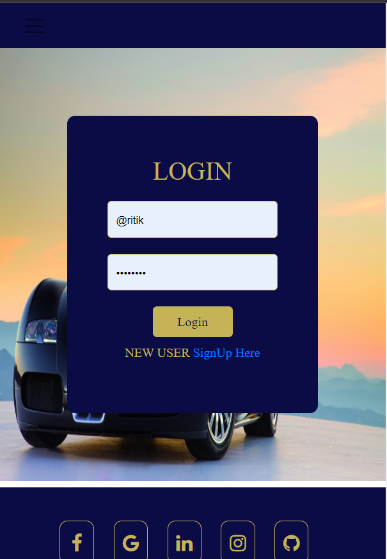

If we click on contact us link the contact us page will appear and we can send message from that page:

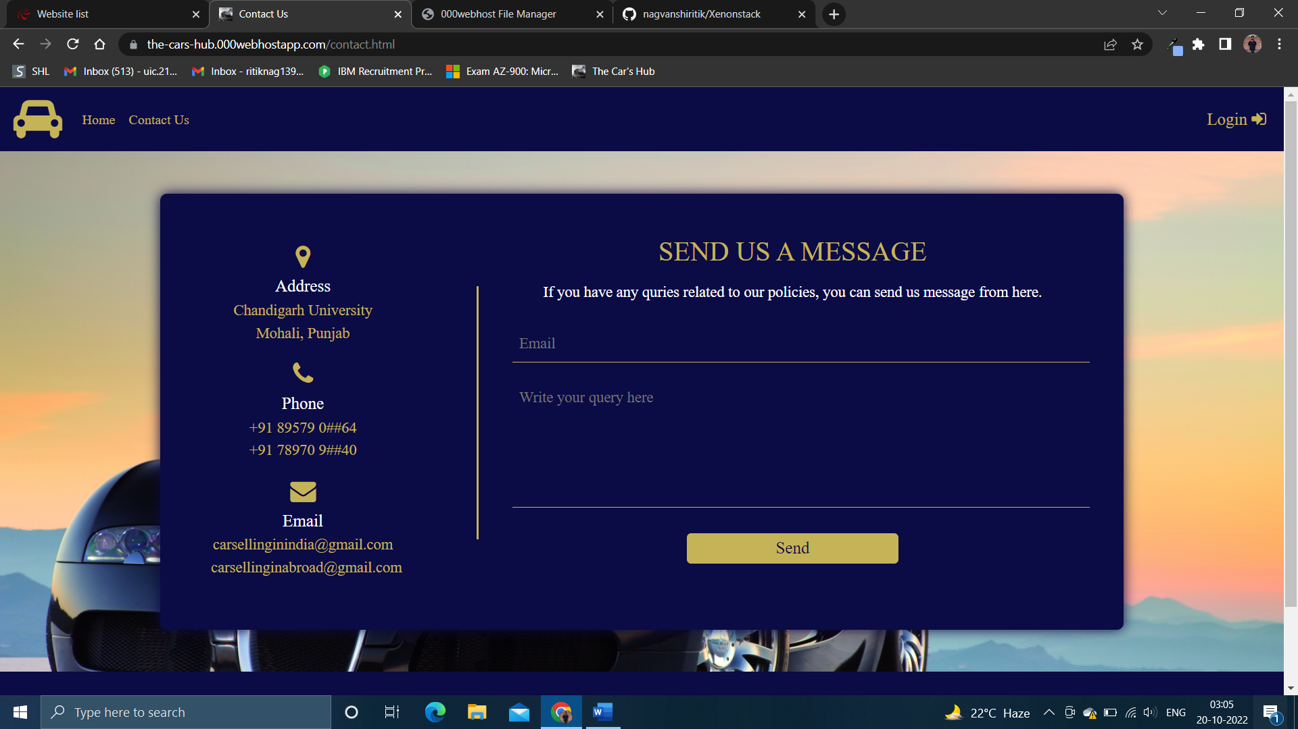

If we open in mobile it look like:

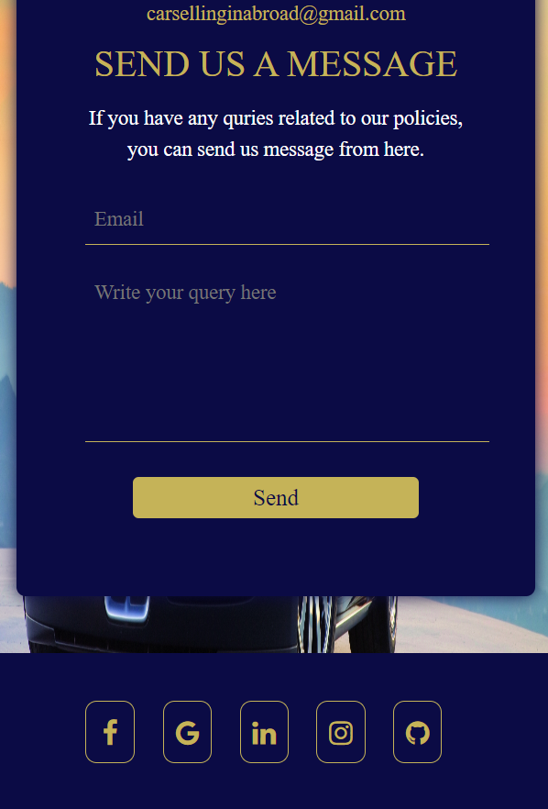

1. STEP 3: If login from the login using default user id and password:

Username: @ritik

Password: Nag@1234

A new page will open where we can see all the second hand cars that are available for sale with all its details.

To buy we all need to do is simply make a call on the number that is being provided there.

After login the page will appear like:

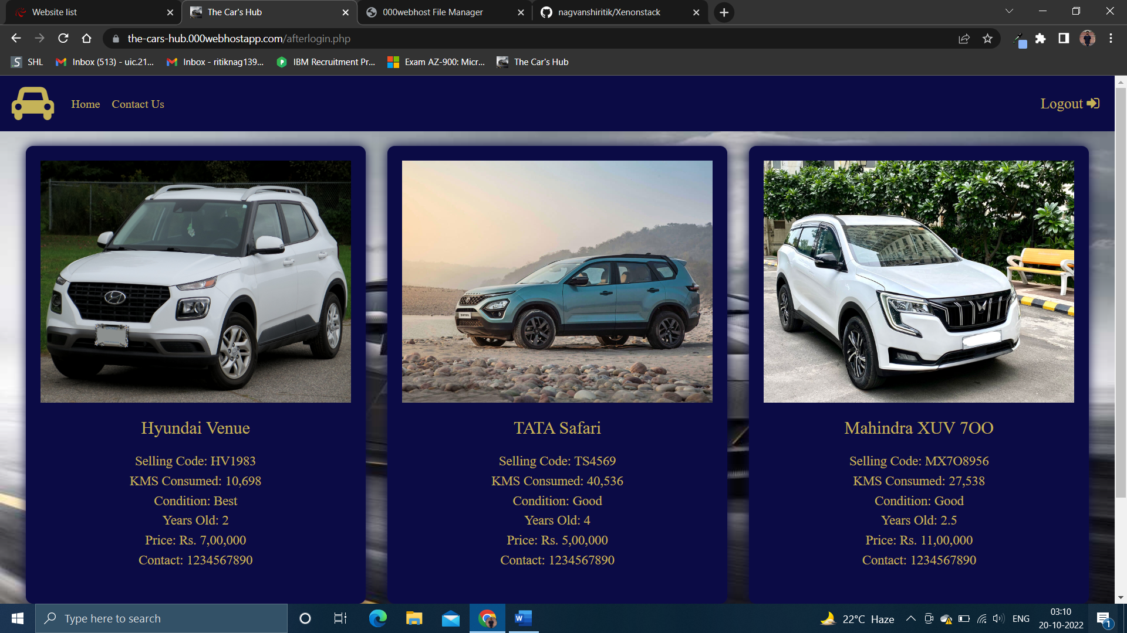

If we open it in mobile it will look like:



1. STEP 4: After login we can simply logout by clicking on the logout button and after logging out it will redirect back to login page.

**SUMMARY**

* *Link to access the project:* [*https://the-cars-hub.000webhostapp.com/*](https://the-cars-hub.000webhostapp.com/)
* *Complete project is uploaded on github :* [*https://github.com/nagvanshiritik/Xenonstack.git*](https://github.com/nagvanshiritik/Xenonstack.git)
* *Hosting Site:* 000Webhost
* *Languages used: HTML, CSS, Bootstrap, Mysql, PHP*
* *Accessibility: Can easily be accessed using device of any resolution.*
* *Flowchart:*

Index.html Contactus.html

Login

After login page

(Car selling page) Contact us page

Logout